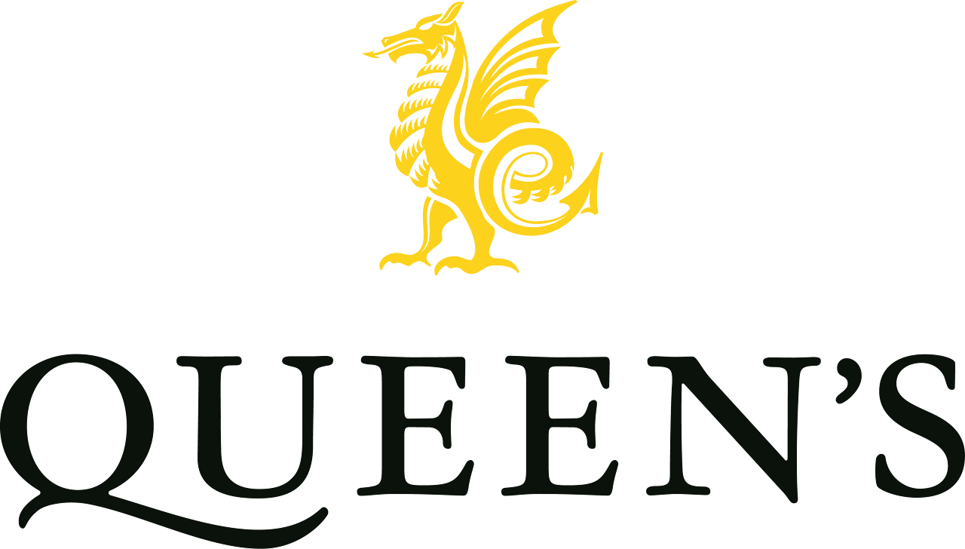

Queen’s College, Taunton is one of the leading independent boarding schools in the South West of England, educating more than 500 boys and girls aged 1 to 18 years, both day and boarding, and is part of the Methodist Independent Schools Trust.
Netball Academy Lead Coach
Zero hours contract (c6 hrs p.w)
Queen’s College, Taunton is seeking an inspirational, enthusiastic and passionate Netball Coach to join our Sports Department. This is a fantastic opportunity for someone who is driven to develop young players, think creatively and inspire a genuine love of the game.
You will deliver engaging and well-structured coaching sessions for pupils across the school, supporting those discovering netball for the first time as well as those developing their skills in a competitive environment. You will also play a key role in the early development of our netball academy, bringing energy and innovation as you help shape an ambitious and growing programme.
You will play an important role in building confidence, teamwork and game understanding, helping to create a positive sporting culture built on commitment, respect and enjoyment.
We are looking for a coach who is innovative in their approach, confident in working with young people and has a strong knowledge of netball. A recognised coaching qualification, or a willingness to work towards one, would be advantageous. The successful candidate will be an excellent communicator who can inspire pupils of all abilities and contribute positively to our busy and ambitious sports programme.
In return, we offer a competitive hourly rate, excellent sports facilities and the opportunity to be part of a supportive and forward-thinking sports department where you can make a genuine impact on the sporting lives of our pupils.
Queen’s College is committed to safeguarding and promoting the welfare of children. Applicants must be willing to undergo child protection screening appropriate to the post, including enhanced DBS checks.
A full job description and application form can be found at
https://www.queenscollege.org.uk/vacancies/
Please have a look at the benefits of working at Queen’s linked below
Benefits of working at Queen's College
All applicants must complete the Queen’s College application form and completed forms should be emailed to vacancies@queenscollege.org.uk.
We do not accept CVs. No agencies please.
For further details about the role please contact Emily Turner, HR Manager ext@queenscollege.org.uk
Queen’s College is committed to safeguarding and promoting the welfare of children, young people and adults and expects all staff to share this commitment. Successful applicants will undergo child protection screening appropriate to the post including checks with past employers and with the DBS. We embrace diversity and welcome applications from all sections of the community.

