Tariq Aziz  55 Century Square  Alma Road  Peterborough  PE1 3FR  (+44) 7307999008  Tsania1721@outlook.com  ECB Level 3 coach of the year award  ICC-Portuguese International Cricket Player and head Coach. Huntingdonshire county Coach Level 3 + Strength and Conditioning level 2 (Leeds University) | 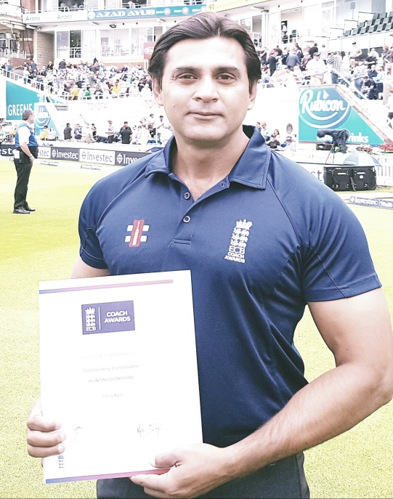

Personality 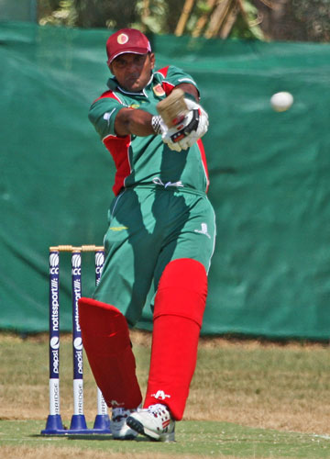 | Cricket is a way of life to me and I am extremely passionate about it and always in pursuit of making things better. I therefore enjoy a lot of respect amongst cricketing circles as an excellent cricketer and coach. I’m an absolute team player that has always been able to be the driving force in the teams I play and I love to lead by example.  Being an excellent and technically sound communicator who is a student of the game, I have always been able to give useful advice to help others to improve.  Joyful person who genuinely enjoys roles requiring extensive human contact. Comfortable communicating with people of various culture and background. A well-presented, articulated and confident individual with a proven ability to provide exceptional cricket coaching and ensure that clients leave with a lasting positive impression. I am enthusiastic, reliable, organised and hardworking. My motivation, great sense of humour and positive nature enable me to relate to people at all fitness levels and ages, and I often prove to be a great role model for young athletes.

Achievements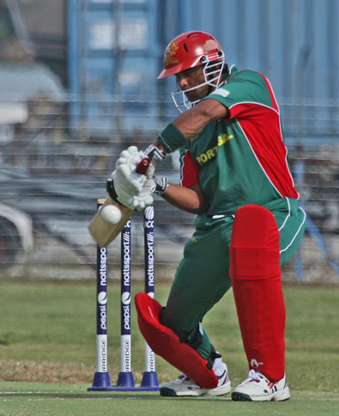 | - 2021-European national championship T10 Head coach and player  - 2019- European triangular series Iberia cup T20 Head coach and player  - ICC Europe T20 Championship Head Coach of Portugal  - 2018 and present  - Head Coach St, Giles Cricket club 2018  - Strength and Conditioning for Sport CPD 16 REPs  - ECB Performance and video analysis  - ECB Training interventions and methods  - ECB Coaching Teams  - East of England county cricket coach 2014-Present  - Head of Cricket coach Kings Camp UK 2014  - Cricket coach in Jackhunt School Peterborough UK 2014  - Head coach of Peterborough Cricket Academy (UK) 2013  - 2012- Award of 4th most valuable player in I.C.C. T20 cricket championship in Corfu (Greece) , whilst representing the Portuguese team as a player as well as assistant coach.  - 2007-I.C.C. 50 overs cricket championship representing Portugal.  - 2006 – Holland playing Amsterdam winners of the league  2005- 2nd best player of I.C.C. 50 overs representing Portugal  - 2002/2004 – plying cricket in Portugal and Holland  - 1998- First class cricket for Pakistan  - 1993/1994 – Pepsi Pakistan U19s

