Ben Saul-Georgel
Hockey Coach
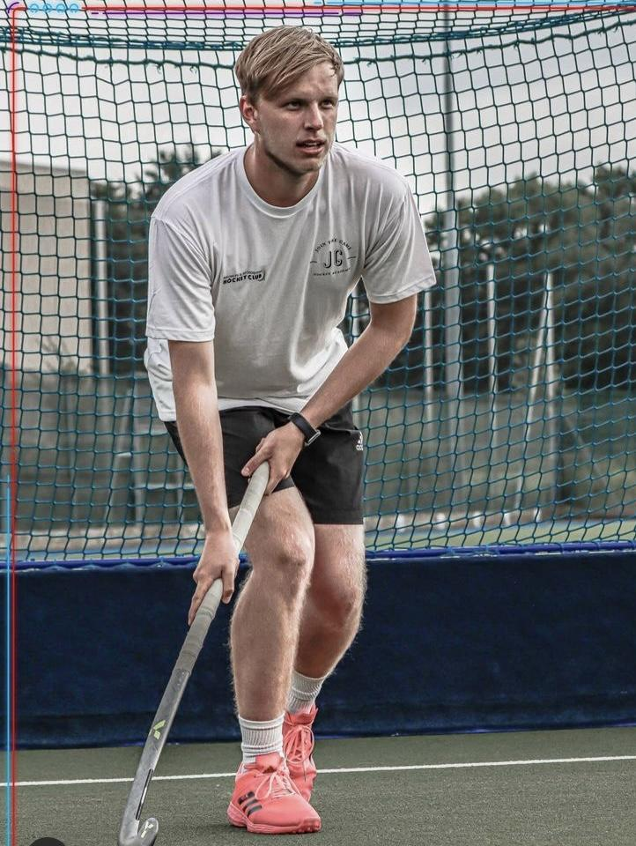

Education
Sheffield Hallam University
September 2019 - May 2022
BSc (Hons) Sport Coaching
Grade: First Class Honors

Langley Park School for Boys
September 2012 - June 2019
3 A Levels
- Physical Education, C (June 2019)
- Sociology, C (June 2019)
- Psychology, E (June 2019)

9 GCSEs
- Physical Education, B (June 2017)
- Drama, B (June 2017)
- Music, C (June 2017)
- Additional Science, C (2017)
- English Language, 5 (June 2017)
- English Literature, 4 (June 2017)
- History, C (June 2017)
- Mathematics, 4 (June 2017)
- Core Science, D (June 2016)
ICT BCS Qualification (June 2017)

Work Experience
Bromley & Beckenham Hockey Club – Coach
Director of Junior Hockey (Current)
Supporting coaches and volunteers delivering weekly training sessions and ideas for match days.
Regularly updating supporting documents for coaches that have drills, and terminology to help create a consistent coaching environment for the junior players.

Creating and leading new coaching sessions for the junior players, providing more opportunities to play the sport.
Lead coach for the U16 boys team.
Provide cover for coaching sessions or matches if age group coaches cannot make the slot.

Club Development Coach (2022/23)
08/2018 - Current
Plan and deliver sessions for holiday camps. Managed and led 4
junior coaches to deliver hockey camp for 25+ 6–16-year-olds.
Summer of 2021, coached team of 20 U18 boys to national plate
quarter final. Summer 2021, I was the assistant coach for the DC and
AC sessions held at the club and involved in the assessment stage
as well as the coaching.
Lead coach for U18 boys (National Tier 2 Champions 2024)

2022/23 season – Lead coach for U16 boys (National Tier 2
Champions & London Tier 2 Champions 2023)
Lead Coach for the U16 Girls
Men’s Club Coach
2023/24 season- Lead Coach for the U16 Boys & U18 Boys

Langley Park School for Boys – Head of Hockey
01/24-08/24
Organise and host weekend fixtures for all the school teams for the
Winter term.
Communicate with Heads of Hockey at other schools to ensure
plans are confirmed, and fixtures are in place.
Plan and deliver hockey sessions to the Year 9 and Senior Squads of
the programme.
Assist training sessions and fixtures for other coaches (umpiring,
leading smaller groups)

2022/23 – Cover Coach
Cover classes when teachers were absent.
Lead the Year 9 hockey team, plan and deliver sessions and coach
fixtures.
Support the rugby teams during the Autumn term.
Lead the tennis team in the Summer term. Organising fixtures and
tournaments, and running weekly squad sessions.
Assist the PE department for the school (clean cupboards, admin for
GCSE moderation, assist with lessons)

Sheffield Hallam Hockey Club - SHU Men’s 2nd XI Coach09/2021- 03/2022
Plan and deliver one training session a week. Coached group of 16
players aged 18-24 to BUCS Northern Conference Cup Semi Finals &
4th in BUCS Northern Tier 2B League.

Sheffield Hallam Hockey Club - SHU Men’s 3rd XI Coach
09/202 - 12/20
Plan and deliver one training session a week. Coached group of
25+ players, some of whom were development players before the
second national lockdown.

The Park Langley Club - Young Tennis Leader
08/2014 - 08/2015
Helped lead and coach sessions of 5-30 children in mini red sessions.

Sporting History
Hockey - National, Regional, County & Club Level
- National League Division 1 North Player 2021/2022
- School Games 2018 (England red)
- University 1st XI VC 2021/2022
- Kent U16 Captain 2016
Tennis - Club, School & County player 2005-2015
Table Tennis - School 2017
Handball & Football - London Youth Games 2011/2012
Skiing

Profile & Further Information
I’m a reliable, trustworthy, hardworking individual committed to always doing my best. I work equally well in a team or on my own and relate well to people of all ages. I have great communication skills. I am seeking a new role as a hockey coach to enhance and apply my knowledge in a good community.

PHONE NUMBER: 07757283022

Linkedin: https://www.linkedin.com/in/ben-saul-
georgel-6a786a1a2/
EMAIL ADDRESS: b.georgel@outlook.com

QUALIFICATIONS
FIH Level 1
FIH Level 2 (completed on 3rd June
2022)
Sport Coaching Hons (1st Class)

INTERESTS, ACTIVITIES &
AWARDS
Cooking
Travelling
Computer Literate (PC & MAC)
Full Clean Driving License

